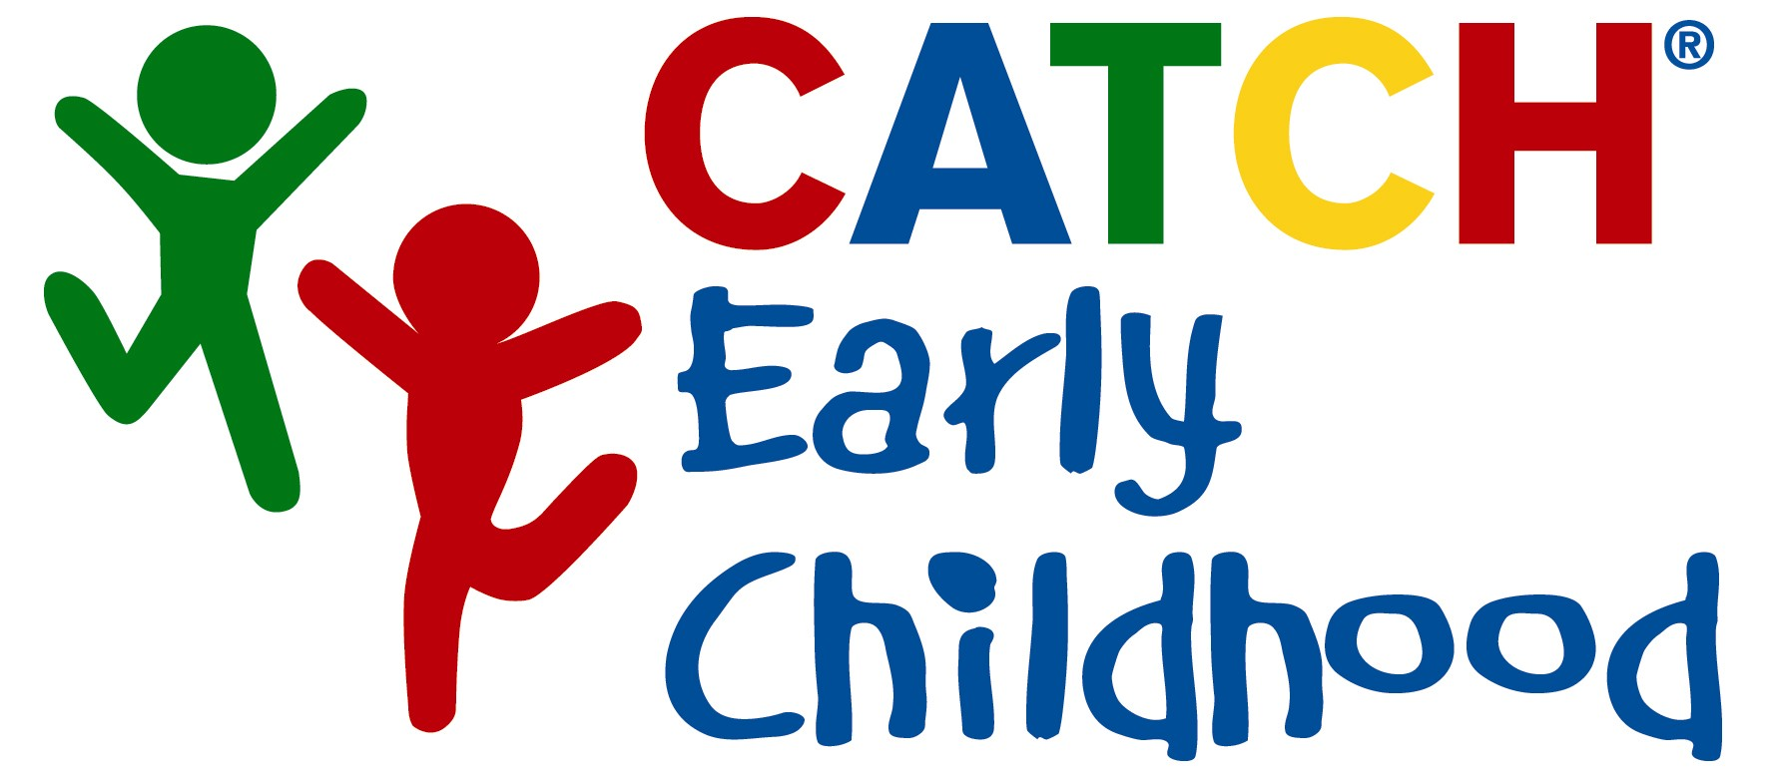

Training Workbook

This workbook is provided to participants of the CATCH Early Childhood Training Workshop. Key points and highlights from the CEC Training are included with additional space provided for individual notes, observations, or questions.
Intended to facilitate higher-level cognitive skills, feel free to document and doodle during your CEC Training experience.

Peter Cribb, MEd
CATCH Project Director
peter.w.cribb@uth.tmc.edu

The University of Texas
Michael & Susan Dell Center for Healthy Living
3445 Executive Center Drive, Suite 150
Austin, TX 78731

(512) 346-6163

Fax (512) 346-6802

CATCH on the Internet
www.CATCHUSA.org
- Handouts and resources
- Information about CATCH components
www.CATCHInfo.org
- Information about what’s going on with CATCH around the nation
- Monthly newsletters

CATCH Early Childhood
Implementation Training

Agenda

Morning Session:

□ Welcome & Introduction
- Health Status
- CATCH and CATCH Early Childhood

□ Break

□ Activity Demonstration

□ Making it Happen: Physical Activity

□ Activity Demonstration

Afternoon Session:

□ Making it Happen: Nutrition

□ Activity Demonstration

□ Break

□ Now what?
- Planning to make a difference

Why are we here today?

Our purpose today is to provide you with the knowledge and skills to successfully implement CATCH Early Childhood. The objectives for the day will help guide you in understanding the process of implementing the CATCH Early Childhood Program.

C larify and identify the objectives of CATCH Early Childhood.
A ddress the national health epedimic.
T arget things in your area of specialty that you can do to begin implementing the CATCH Early Childhood philosophy.
C oordinate, highlight & share with others the things you are already doing that create a healthy learning environment.
H ave Fun!

More children in this country are overweight than ever before, more than triple the number who were heavy in the late 1970s. Children who are overweight are more likely to develop diabetes and other chronic disease risk factors like high blood pressure or high cholesterol. The graph below shows the increase in obesity rates of children ages 7-13 over the past few decades.

Sources: Medline, 2006;Ogden et al. JAMA;195:1549-55; Hedley et al. JAMA;291:2847-2850; Ogden et al., 2008; Ogden et al., 2010; Ogden et al., 2012.
Equal or greater than 95% age/sex CDC Growth Charts
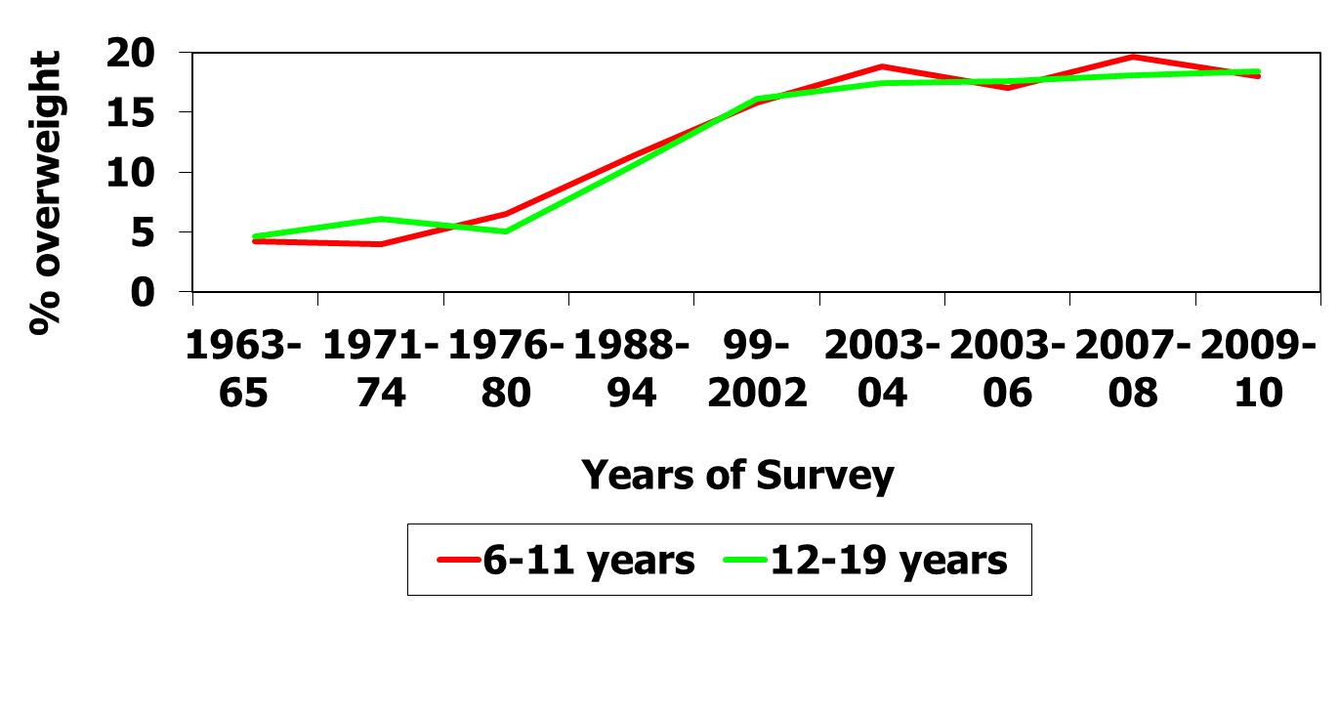

Health Status of the United States

Following are a few of the latest statistics from the Centers for Disease Control and Prevention (CDC):

- The estimated annual cost attributable to obesity-related diseases is approximately $100 billion.
- Results from the 1999-2004 National Health and Nutrition Examination Survey (NHANES), using measured heights and weights, indicate that an estimated 18 percent of children and adolescents (about 9 million young people) ages 6-19 years are overweight. Medline, 2006. Ogden et al. JAMA;195:1549-55, Hedley et al. JAMA;291:2847-2850.
- Obesity increases the risk for type 2 diabetes, hypertension, dyslipidemia, cardiovascular disease, respiratory problems, certain cancers, gallstones, osteoarthritis, and lowered life expectancy.
- Poor eating habits are often established during childhood. More than 60% of young people eat too much fat and less than 20% eat the recommended five or more servings of fruits and vegetables each day.
- Nearly 14 percent of preschool children between the ages of 2 and 5 years were overweight in 2003–-2004, up from 10.3 percent in 1999–-2000. JAMA. 2006;295:1549-1555.
- In addition, the data shows that another 16.5 percent of children and teens between the ages of 2 and 19 are considered at risk of being overweight (BMI from the 85th to 95th percentile). JAMA. 2006;295:1549-1555.

What did you learn about the Health Status of kids and adults that you didn’t know before?
______________________________________________________________________

What is the answer? What can we do?
______________________________________________________________________

What is CATCH Early Childhood?

CATCH Early Childhood is designed to nurture a love of physical activity in children ages 3-5. Modeled after the nationally recognized CATCH® Program, CEC helps to
provide an environment where physical activity, health education, and healthy eating behaviors are valued and taught.

CEC Highlights

- Classroom Curriculum
  - Lesson plans to be taught in the classroom, aimed at promoting healthy eating behaviors. This is in your CEC binder.

- Physical Education Activities
  - More than 150 activities from the activity box to choose from aimed at promoting physical activity so that children can meet the recommended 30 minutes per day of moderate-to-vigorous physical activity (MVPA) per day. With suggestions for variations to each activity, the number of games and activities extends to hundreds.

- Bilingual Parent Tip Sheets
  - Multiple tip sheets in English and Spanish to complement the lesson plans and provide a coloring activity, additional nutrition and physical activity information, tips, and recipe ideas for the parents.
  - Designed to give these to the children to take home to their parents.

These components are designed to promote healthy eating and physical activity behaviors in young children and their families and work together to help prevent the occurrence of diseases such as obesity, heart disease, diabetes etc in adulthood.

- We have also included an adaptive learning component to CEC to meet the needs of children with physical or learning disabilities. These adaptive learning pieces are conveniently located alongside the lessons in the CATCH CEC binder and with the activities in the PE activity box.

- Also, to promote learning in Spanish and French, we have included a list of “key” words from the lesson plans translated from English to Spanish and French that you could use to facilitate learning.

CATCH Early Childhood employs a holistic approach to child health by targeting multiple aspects of the school community and involving teachers, students, students’ families, and the broader school community in a range of health promoting activities. Preliminary evaluation of CATCH in Early Childhood has demonstrated good feasibility and acceptability among children ages 3-5 in preschools.

CEC Physical Activity Component

Goals for CEC Physical Activity

GOALS FOR SCHOOLS:
- Encourage teachers to provide fun Physical Education/Activity a minimum of 3 times each week, preferably every day.
- Provide an environment where physical activity, health education, and healthy eating behaviors are valued and taught.

GOALS FOR TEACHERS:
- Engage all students in enjoyable MVPA for at least 50% of Physical Education/Activity class time every day using the CATCH Early Childhood PE box and the sample schedule outline.
- Use appropriate and effective classroom management and instructional methods. Adopt healthful personal behaviors to provide an active, enthusiastic role model for students.
GOALS FOR CHILDREN:
- Enjoy physical activity and identify basic healthy food choices.
- Acquire knowledge, healthful attitudes, and skills through physical education and/or activities.
- Stimulate a physically active lifestyle.

Key Objectives of CEC Physical Activity

- CEC physical activity is fun & enjoyable.
- Provide children with at least 30 minutes of physical activity daily & be involved in MVPA (moderate-to-vigorous physical activity) for 50% of physical activity time.
- Children are provided with many opportunities to participate and practice skills.
- Encouraged children to participate in a variety of physical activities in school, after-school, and with family & friends.

CEC Physical Activity Component

The Language of CEC Physical Activity

- Skitter Skatter
- Parade Around
- “Bubble” of Space
- Criss-Cross Applesauce
- Eliminate elimination games
- Challenge by Choice
- The “When” before the “What”
- “GO” Activities = Increase MVPA
- “CATCHify” old favorites
- Integrate GO/WHOA food language
- “CATCH” them making healthy choices!

The Language of CEC Physical Activity is designed to maximize participation and make physical activity time more productive.

Children are natural movers. CATCH Early Childhood PE is designed to teach children to have fun while exercising and developing locomotor, non-locomotor, and manipulative skills. Competition, in fact, is considered developmentally inappropriate for preschoolers, as they have not yet achieved the cognitive or social/emotional development necessary to understand or handle competition. Therefore, CATCH Early Childhood PE includes no competitive activities and should always be non-threatening and FUN!
List a few activities you think would fit in each category:

Traditional- Low MVPA CEC Philosophy – High MVPA
______________________ ______________________
______________________ ______________________
______________________ ______________________

CEC Physical Activity Component

CATCH Early Childhood Activity Box

AT THE HEART OF PHYSICAL ACTIVITY
Ready, Set, Go! Time To Teach!
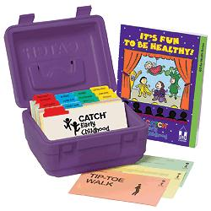
Scope and Sequence with Sample Lesson Plans

CLASSROOM MANAGEMENT ACTIVITIES

WARM-UP & COOL DOWN

GO FITNESS
Mighty Muscles Limber Limbs Hearty Heart

GO ACTIVITIES
Body Management Locomotor
Parachute Throwing & Catching
Striking Dribbling & Kicking
Rhythms Nutrition & Gardening Games

CATCH Early Childhood Sample Lesson

WARM-UP - The WARM-UP prepares the body for the vigorous activity to follow, as well as reduces the likelihood of injury. (3-5 minutes)

GO FITNESS – The GO FITNESS activities are intended to promote muscular strength, muscular endurance, and cardiovascular endurance. (5-7 minutes)

ACTIVITY - The “GO” ACTIVITIES are the main activity/focus of the day that are designed to increase MVPA. (5-7 minutes)

COOL-DOWN - The COOL-DOWN involves tapering the level of intensity to help children’s bodies return to a normal level. (3-5 minutes)

Sample Lesson:
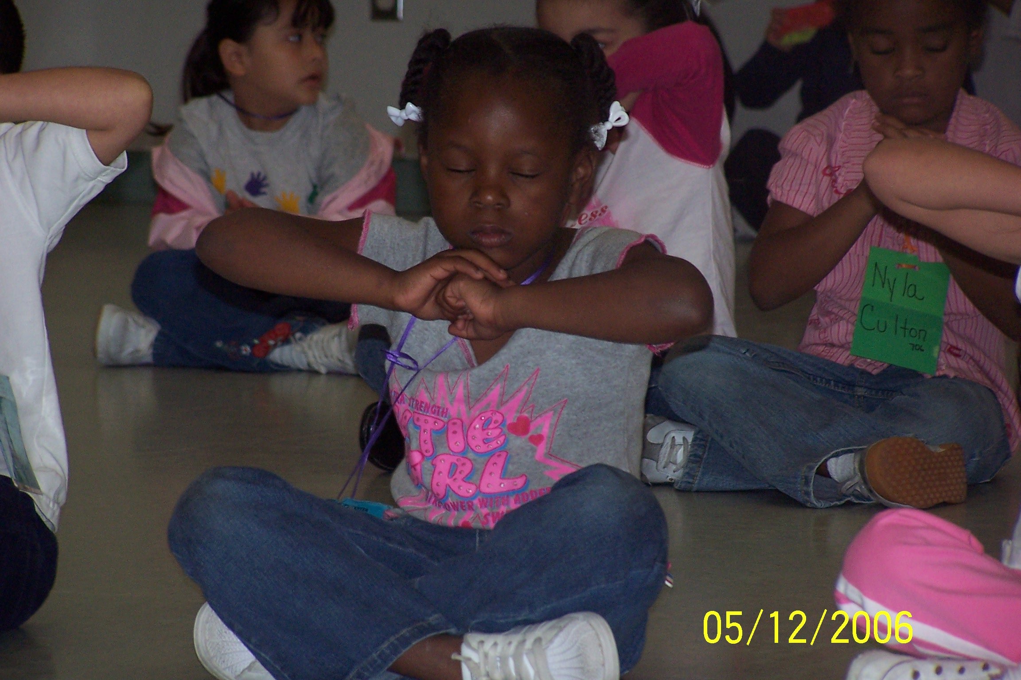
- WARM-UP
  - Count Down
- GO FITNESS
  - Crabs and Seagulls
  - Touch It
- GO ACTIVTIY
  - Frogs & Sinking Lily Pads
- COOL-DOWN
  - Yoga Poses
The BASICS

Behavior Management Strategies
Or

“How to Survive Group After Group of Pre-Schoolers”

CATCH Early Childhood BASICS

B
Boundaries and Routines

I

A

S

C
Activity from the Get-Go
Stop and Start Signal
Involvement by All

Concise Instructional Cues

S
Supervision

Keys to Success

Establish and publicize your expectations: Post the expectations, talk about them, and have students recite them. Make sure your students know what is expected.

Deal with off-task children: Give them a leadership role, like carrying equipment or going out early to set up the cones.

Establish routines, routines, routines: Important routines to establish include: stop/start signal, walking the boundaries, listening to teacher while holding equipment, time-out procedures, getting children into groups.

Watch for the following


This checklist has been prepared for staff to assess demonstrations during the CATCH Early Childhood training and on yourself. Circle “Yes” or “No” for each item. Comments for discussion purposes may be written below each item.

- Were children active right from the start? YES NO

- Did the activity session include a warm-up activity? YES NO

- Were the boundaries well established? YES NO

- Was the stop/start signal clear? YES NO

- Were the instructions clear and concise? YES NO

- Was equipment distributed efficiently? YES NO

- Were management and transition times minimal? YES NO

- Did group sizes maximize participation and
practice opportunities? YES NO

- Were all children involved? YES NO

- Was the child:equipment ratio adequate? YES NO

- Were activities conducted in a safe manner? YES NO

- Was the staff enthusiastic about the activities? YES NO

- Did most of the children appear to be enjoying
the activities? YES NO

- Were children praised/rewarded for being
physically active during class? YES NO

- Were children prompted/rewarded for their
out-of-class physical activity? YES NO

- Did the activity session include a cool-down activity? YES NO

CEC Classroom Curriculum

Key Objectives of CEC Classroom Curriculum

What is the classroom curriculum trying to do?
- It’s fun to be healthy! is aimed at promoting healthy eating behaviors in preschool age children, ages 3-5.

- The age and developmentally appropriate lesson plans have been developed by childhood curriculum experts. Each lesson, using fun themes and activities, introduces the preschoolers to nutrition concepts thus enabling them to make healthy food choices.

CEC Classroom curriculum
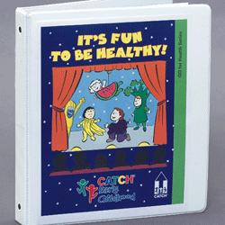
- Nutrition Lessons include:
  - A variety of topics including GO and WHOA Foods
  - Planning Notes
  - Behavioral Objectives
  - Extension Activities
  - Curriculum Connectors
- Parent Tip Sheets
  - Newsletters to parents relay information about what their child is learning, tips, and fun recipes to try at home.
- FYI Section
- The FYI section is at the end of the manual and provides additional information on topics such as: GO and WHOA Foods, The Importance of Physical Activity, Fruits and Vegetables, Eat Smart School Meal Program, Beverages, Snacks

CEC Classroom Curriculum

Gus Goodfood Helps a Friend

- In Lesson 1, the learner is introduced to Gus Goodfood and healthy eating behaviors.
  - GO Foods
  - WHOA Foods

- The “Curriculum Connectors” help extend the lesson into other learning centers. In Lesson 1, the Curriculum Connector for a Language Center is to have the children work with the illustrations to re-tell the story. What other curriculum connectors can you think of?
______________________________________________________
______________________________________________________

- What are some extension activities that you could create from this lesson? _______________________________________________________
_______________________________________________________

- How could you incorporate the lesson’s messages into a physical activity?
_______________________________________________________
_______________________________________________________
List a few foods you think would fit in each category (that are not mentioned above):

GO Foods WHOA Foods

______________________ ______________________
______________________ ______________________
______________________ ______________________
______________________ ______________________
______________________ ______________________

Strategies and Techniques

to Minimize Off-Task Behavior

- Preplanning: Planning around peak distraction times.

- Perimeter: Move around the outside facing into the activity area. Make sure none of your children are behind you when you are monitoring or giving instructions.

- Proximity: Know your trouble spots and stand near them.

- Pace: Keep your activities flowing and everyone moving. Be aware of children getting tired or bored and be ready to move on to the next activity.

- Praise: Let your children know when they are doing well. Positive feedback from both staff and children encourages participation.

- On-the-Ball: Stay alert for any disruptive behavior. Addressing any problem early and in a direct manner will help you avoid any serious problems later on.

- Selective Ignoring: Making a judgment call about when/when not to intervene.

- Visual Reprimand or Signal: Using a stare, uplifted eyebrow, or a flip of the lights.

- Verbal Reprimand

- Time-Out: Use short periods and inform children why they are being placed in Time-out.

Taken From: Graham, G. (1992) Teaching Children Physical Education and T.Shrigley, (September 1979) “Strategies in Classroom Management,” NASSP Bulletin
CEC RULES
- Stop, Look, and Listen
- Share and Take Turns
- Be Kind to Others
- Take Care Of Equipment
- Don’t Touch Others When Moving

Routine Planning

Think about your children, your teaching style, your past experience in PE and in the classroom, and what you know about class management and routines. Now, come up with some routines that you think will work for you during physical activity time. Creating routines will help your activities run more efficiently, and there will be fewer breaks for directions/instructions and more time for activity.

How will my children line up to go to Physical Activity?

Who will deal with equipment? How will I teach children how to look after it?
______________________________________________________________

How will my activity time begin? Will we always start in the same area? When my group arrives at the activity area, what will they do?
______________________________________________________________

What is my start signal? How will I give it?
______________________________________________________________

What is my stop signal? What will my children do when I give this signal?
______________________________________________________________

What strategies will I use to get children into groups?
______________________________________________________________

How will I distribute and collect equipment?
______________________________________________________________

What will my plan be when children ask to go to the restroom or to drink water?
______________________________________________________________

What will I do with children who say they don’t feel well? What will I expect from special needs children?
_____________________________________________________________

How will I handle emergencies during Physical Activity (e.g., injuries, fire alarms)?
______________________________________________________________

How will I close my activity time every day?
______________________________________________________________

Establishing Routines in CEC

Sample Routines

Lining Up Students:
- Alphabetical order by first name or last name
- Height
- Birthdays
- Classroom groupings
- CEC squads (four or five per group)
- Color of eyes, hair, clothes
- Pet owners, non-pet owners

Getting Class Started:
- Use a pre-set, initial activity like walking around the boundaries.
- The beginning of each activity time is a good time to review/reinforce the start/stop, boundaries and the CEC rules.

Response to Stop Signal:
- Give a stop signal (verbal command, like "STOP", "FREEZE", whistle, clap, raised hand, drum, etc), then count, "One, two, three." By three, all children must be quiet, with eyes on teacher.
- Use a combination, like "STOP" and a raised hand. Have all children raise their hand to indicate their readiness to listen.
- Use the same stop signal consistently.

Response to Start Signal:
- Say the when before the what: "When I say go, you will move to the perimeter. Ready, Go."
- Use the same start signal consistently, AND use a signal that is different from the stop signal. For instance, whistle for stop, "Go" for start.

Listening to Teacher:
- Verbal command, "Voices off, focus on me."
- Instruct children to sit or to kneel on one knee. (May not be appropriate if outside).
- Be sure to position yourself so children are faced away from the sun or other distractions.

Establishing Routines in CEC

Listening to Teacher while Holding Equipment:
- Instruct children how to hold equipment in "home position" while listening to teacher.
- Ball: bear hug ball or hold ball to belly button.
- Ball: on ground between feet.
- Hoop: stand inside of hoop.
- Frisbee: hold in right hand or place on ground.
- Other equipment (bean bags, yarn balls, etc.): place on ground next to feet.

Selecting Partners or Groups:
- Body Parts (e.g., shoulder to shoulder, back to back, toe to toe).
- Share a hoop.
- Magic clips.
- Color of clothing
- Try to get children into groups within 30 seconds.

Distributing & Picking up Equipment:
- Call on children using groups listed previously.
- As children move around the perimeter, hand out equipment or tap children individually to go get a piece of equipment.
- To minimize off-task behavior, assign children a task as soon as they get a piece of equipment OR instruct them to hold their equipment in the designated home position until everyone is ready.

Making Transitions from One Activity to the Next:
- Instruct children to walk around the boundaries.
- Use Skitter Skatter to put children into new groups.

Supervising/Monitoring Class Activity:
- Teach from the perimeter, not the middle of the activity area.
- Position self where eye contact can be maintained with all children.
- Scan area frequently.

Ending Class:
- Review body cues experienced during class.
- Encourage participation in physical activity before and after school.
- Give positive feedback for participation.

Connecting CEC


How will you raise awareness about health and wellness with parents and your community?

________________________________________________________________________________________________________________________________________________________________________________________________________________________________________

How can you help connect your organization to the community to promote health and wellness?

________________________________________________________________________________________________________________________________________________________________________________________________________________________________________

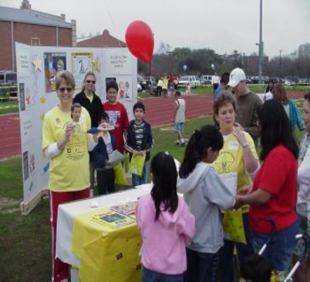

What are some goals you would like to set to improve community awareness surrounding health and wellness?

________________________________________________________________________________________________________________________________________________________________________________________________________________________________________

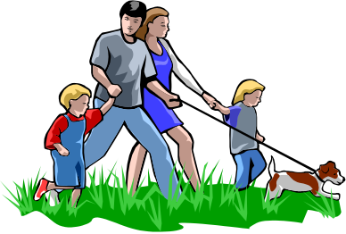
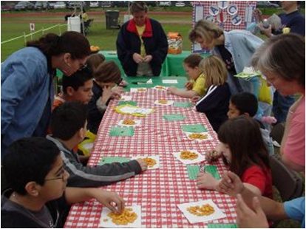

OBJECTIVE | ACTIONS | RESPONSIBLE  PARTY | TARGET  DATE | COMPLETION  EVIDENCE
1. Obtain the CEC Curriculum.

2. Attend a CATCH Early Childhood (CEC) Training.

3. Familiarize yourself with the CEC Curriculum.

4. Pilot CEC physical activities and nutrition sessions with small groups.

5. Establish procedures to continue & maintain program implementation.
CEC Action Plan

Review the five objectives and plan appropriate actions to build sustainability within

your program. The key to sustaining your CEC Program is finding out what works for your site!

Am Do, Can Do, Will Do

AM DOING | CAN DO | WILL DO
List things you are already doing that correlate with the CEC objectives to create a healthy environment. | Identify new things that you can begin doing immediately. | Identify things you would like to incorporate but require more time and planning.

CATCH Early Childhood Planning Tool

DAY | WEEKS
DAY | Week 1 | Week 2 | Week 3
Monday
Tuesday
Wednesday
Thursday
Friday
Remember, “Inch by inch it’s a cinch. Yard by yard, it’s too hard.” Bonnie Hopper

Your CATCH Program Just Begins With Training!
The CATCH Team has a variety of resources available as you explore the implementation and growth of CATCH in your community including:
Evaluation Tools
Partnership Opportunities
Grant Writing Assistance
Expanded Staff Training
Questions?
Email: info@catchinfo.org
Call: 800-793-7900
Visit us Online!
CATCHINFO.org or CATCHUSA.org




